# REQUEST FOR FINANCING

**Property:** Multifamily Sample

**Requested Loan Amount: ** $ 1,530,000

**Property Located At:** 125-250 Front Street

Valley Park, New Jersey 39944

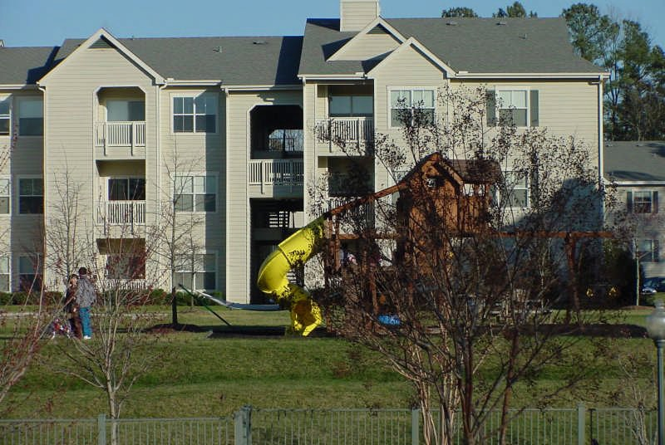

# Executive Summary

Multifamily Sample

Property Type Requested Loan Amount Loan Purpose

Loan Term (Years) Amortization(Years) Requested Interest Rate Loan To Value

Debt Service Coverage Ratio Present Occupancy % Purchase Price

# Underwriting Reserves

Min. Vacancy Reserve Min. Management Fee Replacement Reserve

Multifamily

$ 1,530,000

Purchase 10

30

7.300%

80.0%

1.23

91

$ 1,900,000

5.0%

4.0%

$ 250/Unit

# Summary

The subject property is a multi-story apartment complex constructed in 1996 and renovated in 2000. The complex consists of 2 buildings with a total of 36 apartments. The unit mix consists of 1BR/1BA and 2BR/1.5BA units in each building.

Multifamily Sample

# Underwriting Analysis

## Loan Information Underwriting Results

Property Type Loan Purpose

Multifamily Purchase

Max. Loan @ Min. DSCR Max. Loan @ Max. LTV

$ 1,558,582

$ 1,520,000

Loan Term 10 yrs

DSCR @ Proposed Loan1

1.23

Loan Amortization

Loan Type Requested Interest Rate Interest Rate Index Current Index Yield

Interest Rate Spread

30 yrs Fixed 7.300%

10 Yr US Treasury 5.150%

2.150%

LTV @ Proposed Loan2 Proposed Annual Debt Svc

Proposed Monthly Pymt Balloon @ Maturity

80.0%

$ 126,307

$ 10,526

$ 1,309,263

Purchase Price Last Appraised Value

$ 1,900,000

$ 1,900,000

## Value Analysis

3

## Underwriting Constraints

Direct Capitalized Value

Direct Capitalization Rate Value at Market Cap

$ 1,900,000

8.50%

$ 1,828,425

Max. LTV

Min. DSCR

Min. Vacancy Reserve Min. Management Fee

80.0%

1.20

5.0%

4.0%

Cap Rate @ Appr. Value

Requested LTV4 Est. Terminal LTV

Loan Constant

80.5%

68.9%

0.08310

Interest Accrual Method Interest Rate Rounding TI/LC Stress DSCR Rent Roll Start Date

Avg. Lease Term (months)

Actual 360

No Rounding 1.10

1/30/2005

12

Purchase Price Cap 8.18%

## Loan Conclusion

Expense Growth Rate Replacement Reserve

3.0%

$ 250/Unit

## Requested Loan Max. Allowable Loan5

$ 1,530,000

$ 1,520,000

## Notes:

Calculations Notes

1. DSCR @ Proposed Loan (NCF / Annual Debt Svc)
2. LTV @ Proposed Loan (NOI - Cap Ex / Cap Rate)
3. Cap Calculations based on (NOI - Cap Ex)
4. LTV Calculations based on (NOI - Cap Ex)
5. Max. Allowable Loan is the lesser of Max. Loan @ Max. LTV, Max. Loan @ Min. DSCR or Requested Loan.



Multifamily Sam

Matthew Partner



|  |  |  |  |  |  |  |  |  |
| --- | --- | --- | --- | --- | --- | --- | --- | --- |
| **Rent Roll**  Loan Name ple  Borrower Name s  Property Type Multifamily  Building: Front Street Apartments | | | |  |  |  | Multifamily Sample | |
| Unit Type | Occupied Units | | Vacant Units | Avg  Unit Area | Min  Monthly Rent | Max  Monthly Rent | Avg  Monthly Rent | Est.  Market Rent |
| 1BR/1BA | 17 | | 2 | 800 | 950 | 1,050 | 1,000 | 1,100 |
| 2BR/1.5BA | 16 | | 1 | 1,100 | 1,250 | 1,385 | 1,300 | 1,350 |
| **Totals** | |  | | | | | | |
| Total Unit(s) | 36 | | |  |  |  |  |  |
| Occupied Unit(s) | 33 | | |
| Vacant Unit(s) | 3 | | |
| Physical Vacancy (%) | 8.33% | | |
| Economic Vacancy (%) | 8.59% | | |
| Average Rent | $1,145 | | |
| Potential Gross Income | $496,200 | | |
| **Notes** |  | | |
|  | | Page 4 of 11 | | | | | | |



Matthew Partne



|  |  |  |  |  |  |  |  |  |  |  |
| --- | --- | --- | --- | --- | --- | --- | --- | --- | --- | --- |
| **Operating Statement**  Loan Name Borrower Name Property Type | Multifamily Sample  rs  Multifamily | |  |  |  |  |  | Multifamily Sample | | |
| **Income/Expenses** | 2002 | 2003 | 2004 | YTD  Annual | Trailing  12 | Appraisal | Originator  U/W | % | Final  U/W | % |
| Base Rent |  | 480,355 | 488,965 |  | 495,399 |  | 496,200 | 99.4 | 496,200 | 99.4 |
| Laundry/Vending Income |  | 2,366 | 2,880 |  | 2,943 |  | 2,943 | 0.6 | 2,943 | 0.6 |
| Parking Income |  |  |  |  |  |  |  |  |  |  |
| Other Income |  |  |  |  |  |  |  |  |  |  |
| Vacancy & Coll. Loss |  |  |  |  |  |  | 42,853 | 8.6 | 42,853 | 8.6 |
| Effective Gross Income |  | 482,721 | 491,845 |  | 498,342 |  | 456,290 | 100.0 | 456,290 | 100.0 |
| Real Estate Taxes |  | 125,488 | 127,688 |  | 125,688 |  | 131,519 | 28.8 | 131,519 | 28.8 |
| Property Insurance |  | 11,355 | 12,499 |  | 10,388 |  | 12,874 | 2.8 | 12,874 | 2.8 |
| Utilities |  | 61,388 | 65,355 |  | 63,866 |  | 67,316 | 14.8 | 67,316 | 14.8 |
| Repairs and Maintenance |  | 17,855 | 16,573 |  | 15,977 |  | 18,391 | 4.0 | 18,391 | 4.0 |
| Management Fees |  |  |  |  |  |  | 18,252 | 4.0 | 18,252 | 4.0 |
| Payroll and Benefits |  | 12,866 | 12,477 |  | 11,288 |  | 13,252 | 2.9 | 13,252 | 2.9 |
| Advertising and Marketing |  | 1,830 | 1,668 |  | 1,783 |  | 1,885 | 0.4 | 1,885 | 0.4 |
| Professional Fees |  | 2,557 | 3,665 |  | 2,899 |  | 3,775 | 0.8 | 3,775 | 0.8 |
| General and Administrative |  | 20,133 | 20,511 |  | 20,388 |  | 21,126 | 4.6 | 21,126 | 4.6 |
| Other Expenses |  | 3,384 | 2,833 |  | 3,110 |  | 3,486 | 0.8 | 3,486 | 0.8 |
| Ground Rent |  |  |  |  |  |  |  |  |  |  |
| Total Operating Expenses |  | 256,856 | 263,269 |  | 255,387 |  | 291,874 | 64.0 | 291,874 | 64.0 |
| Net Operating Income |  | 225,865 | 228,576 |  | 242,955 |  | 164,416 | 36.0 | 164,416 | 36.0 |
| Cap Ex. (Repl. Reserves) |  |  |  |  |  |  | 9,000 | 250.0 | 9,000 | 250.0 |
| Extraordinary Capital Exp. |  |  |  |  |  |  |  |  |  |  |
| Total Capital Items |  |  |  |  |  |  | 9,000 | 2.0 | 9,000 | 2.0 |
| Net Cash Flow |  | 225,865 | 228,576 |  | 242,955 |  | 155,416 | 34.1 | 155,416 | 34.1 |
| **Notes** |  |  | Page 5 of 11 | |  |  |  |  |  |  |

# Loan Detail

## Loan Borrower Information

Multifamily Sample

Loan Name

Loan Amount Recourse Option

Multifamily Sample

$ 1,530,000

Non-Recourse

Borrower Name Borrower Type First Name Middle Initial

Matthew Partners LLC

John

## Broker Information

Last Name Address 1

Matthewson 100 Main Street

Company Name



Contact Address Address 2

City State Zip

Telephone

Fax E-mail

Broker Pro James Bond 5950 Canog

Suite 400 Woodland Hills California 91362

a Ave.

(818) 737-7050

(818) 704-6300

info@lendingap

ps.com

Address 2

City State Zip

Telephone

Fax E-Mail Net Worth

FICO Score Has borrower filed

bankruptcy

Valley Park New Jersey 06844

(201) 688-4466

(201) 323-2325

[matt@matthewson.com](mailto:matt@matthewson.com)

$ 1,588,888

725

No

# Property Information

Multifamily Sample

Property Name Property Type

Multifamily

Front Street Ap

artments

Property Sub Type No. of Buildings

Land area included with property (acres)

Appraised Value Appraisal Date Date of Last Sale

Sale Price at Last Sale Property located in Central Business District

Did you make physical inspection of the property Property Management Contract in place Ground Lease Expiration Date

Loan Purpose

Low-Rise Garden Apts 2

2.0

$ 1,900,000 1/1/1998

5/21/1998

$ 1,700,000

No Yes No

Purchase

Purchase Price $ 1,900,000 Anticipated Closing Date 2/15/2002

Property is Owner-Occupied Percentage of Subsidized Units

Adjacent to Sewage/Waste treatment facility

% Of Student Housing

% Of Corporate Housing

% Of Military Housing Laundry Rooms

Pools Club Houses Tennis Courts Exercise Rooms Playgrounds

Security Gates Surrounding Land Use

No 5

No

1

Similar Residential

## Notes



**Building Information**

Multifamily Sample

Building Name

Address 1

Address 2

City State Zip

No. of Stories Year Constructed Year Renovated

Overall Appearance and Marketability

Front Street Apartments 125-250 Front Street

Valley Park New Jersey

39944

3

1996

2001

Average

Mircowave Ceiling Fans Fireplace

Air Conditioning

Flat Roof T-111 Exterior Gross Building Area

Yes No No Yes No No

39,600 SF

## Notes



**Underwriting Comments**

Multifamily Sample

Loan Name Multifamily Sample

Matthew Partne

Borrower Name Property Type

rs

Multifamily

LTV Margin The proposed loan is constrained by the minimum Loan To Value (LTV) requirement. Assess the capitalization rate utilized in your analysis. Decreasing the capitalization rate may improve the underwritten LTV.

DSCR Threshold Based on the current and projected Net Cash Flow, the property sufficiently maintains the DSCR requirement throughout the term of the loan. No DSCR deficiencies are noted.

Rental Income Trend Based on a comparison of the Base Rent in the Current Year and the Base Rent in the Prior Year, the income is trending negatively. This variance may warrant normalization of underwritten income. Critically assess this variance.

Subsidized Units If a rent subsidy contract (e.g. HAP or HUD) is present and expires during the term of the loan, consider underwriting the income based on the indicated Market Rent per Unit. You may also want to make allowances (or reserves) for extended vacancies and lease-up.

Property Location Note whether the property is located in a Central Business District (CBD). Generally, properties located within a CBD have greater absorption as compared to properties located outside of a CBD. For properties located outside of a CBD, consider the economic effects of longer vacancy periods during times of lease expirations.

Property Condition Consider the property's date constructed, last renovation, and the physical condition of the property. Provide comments regarding the property's condition as it relates to acceptable market standards. Note if any deferred maintenance items exist. If the property is in need of renovation, or if it exhibits deferred maintenance items, clarify these issues and assess this potential effect on the underwritten cash flow.

Property Management If the property is professionally managed, comment on the quality of the property management company. Consider the company's qualifications and experience, ability to attract quality tenants, tenant mix, minimization of lease rollovers. If the property is self-managed, critically assess the qualifications and experience of the self-manager. Based on the complexity of the property being managed, a certain level of property management experience may be expected of the self-manager.

Net Worth Consider the borrower's net worth. Generally, a higher net worth contributes to the quality of the loan.

Credit(FICO) Score Consider the borrower's credit (FICO) score. Assess and comment on the payment history and the overall credit profile of the borrower.

Vacancy Issues Examine the market and submarket to estimate the effects of new properties or similar space becoming available in the market. Consider the economic effects of proposed new construction on unit absorption.



Multifamily Sample

Property Inspection If you have completed a physical inspection of the property, carefully review your notations made during your inspection. Generally, a physical inspection of the property aids the underwriter in estimating the costs of replacement reserves and the presence of any deferred maintenance. If you have not made a physical inspection of the property, verify the quality and competitive aspects of the collateral by obtaining recent color photographs illustrating the property.



# Photos

Multifamily Sample

Side view of property facing north from Filmore Street.

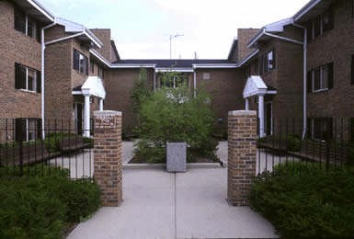View of courtyard area between Building A and Building B.

